User manual for database
QSE Register

Table of Contents
1. Introduction 3
2. Login to the database 4
2.1. Password reset 4
3. Start page 5
3.1. User view, section "Quick Links" 7
3.1.1. Responsible for tickets 7
3.1.2. Responsible for corrective actions 9
3.1.3. Action ready for verification 10
4. Tickets 12
4.1. Ticket list 12
4.2. Create ticket 13
4.3. Ticket details 16
4.4. Ticket modification 16
5. Corrective actions 17
5.1. Corrective action list 17
5.2. Corrective action details 17
5.3. Changing of corrective action state 18
5.4. Corrective action creating 20
5.5. Modification of corrective action 21
6. Walk the talk/Toolbox talks 22
6.1. Walk the Talk/Toolbox Talks list 23
6.2. Create Walk the talk /Toolbox talks 23
6.3. Creating Walk the talk/Toolbox talks report 23
7. User account 24
7.1. My account 24
7.2. Change password 24
8. Reports 25
8.1. Creating “Tickets group report” and “Corrective actions group report” 25
8.2. Creating „Corrective actions group report” 27
8.3. Creating „Ticket details report” 28
8.4. Creating „Walk the talk/Toolbox talks report” 30
9. Pomoc 31
10. Automatic notifications 31
11. Technical support 32

1. Introduction
This instructions contains description of functions of database for users and others useful informations which allows for effective using of the database. The main purpose of the database is possibility to submitting all types tickets (Near Miss, Near Miss Logistic, Near Loss, Near Mess, CAP, DKD, Memo, SMED, Walk the Talk, Improvement actions) and manage them to ensure efficiency and speed of closing incidents and also to provide easy and accurate reporting status and improve existing processes.
All employees CCHBC have access to the database, it is also possible to add external users.
In the case of no access to the database for some users please contact with your local database Administrator (Continuous Improvement Coordinator and Quality Systems Specialist) to add users to the system.
The availability of the database functions depends on the roles assigned to the user
One user can have assigned several roles. The Administrator has extended access to database functions.

2. Login to the database

To log in to the database „QSE Register”, enter following address in the web browser: http://cap.parallel-web.com, the login page of database will be displayed. Provide your e-mail address and password click „Log in”. To use the database without logging every time, please mark checkbox "Remember me?". When you log in first time to database please follow the instruction “Password reset”.

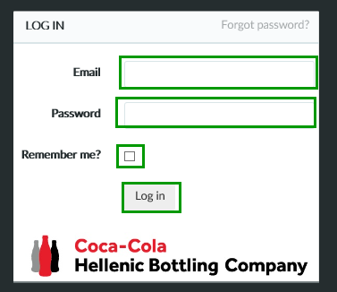

2.1. Password reset

If you forgot your password to your account, you can reset it. Click button in the top right corner „Forgot password?”

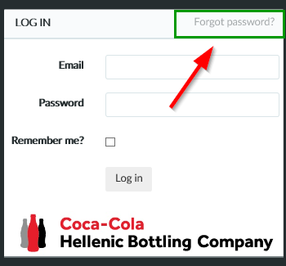

Enter you email address and click button „Send link to email”

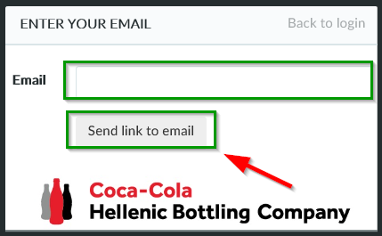

You will receive a message with a link to reset your password.

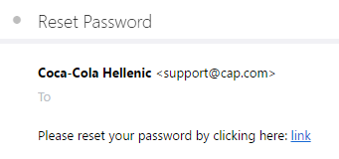

Click the attached link in the email. Enter your email address, new password and then click „Reset” button. After completing this instruction, a new password will be set.

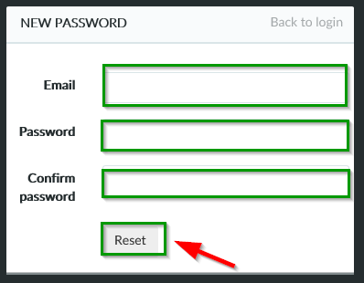

3. Start page
After logging into the system the start page will be displayed.
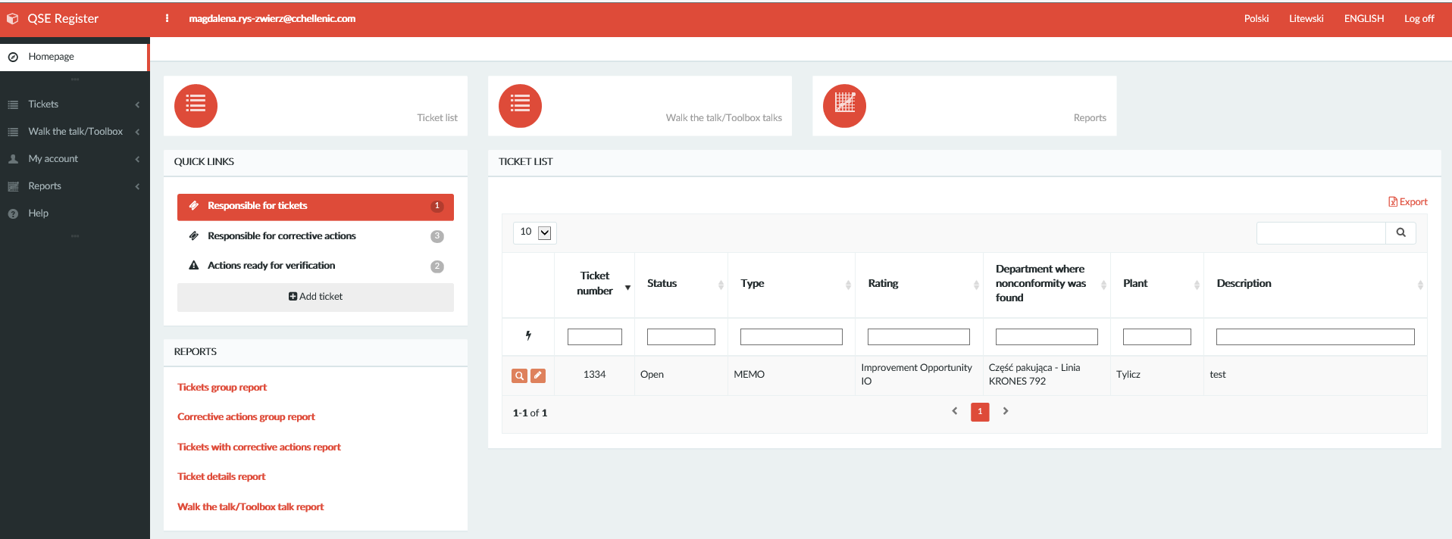

In the top right corner of the bar you can change language and log out of the system. By using „Dots” on the left side of the bar you can hide or show the menu.

On the left you can find a drop-down menu and button “Homepage”.
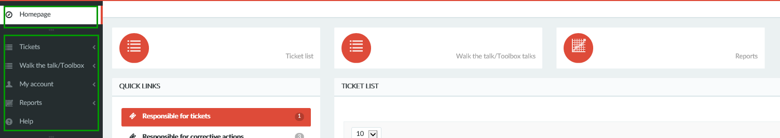

In the middle of the user panel there are buttons for the main functions of the database (Fig.1). User view with assigned tasks to be performed (Fig. 2), and reports links(Fig. 3).

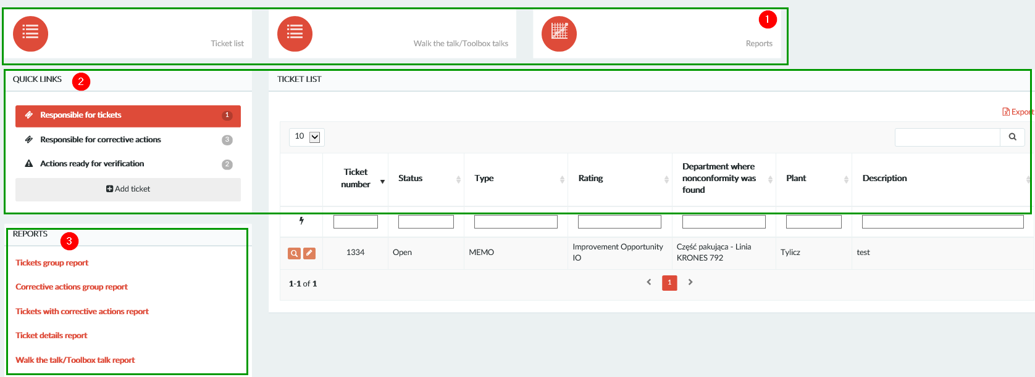

3.1. User view, section "Quick Links"
Widget “quick links” allows for efficient management of tickets in the database. We will find there all assigned to us tasks in three categories:
- Responsible for tickets
- Responsible for corrective actions
- Action ready for verification

There is also a button “Add ticket” for submitting applications.

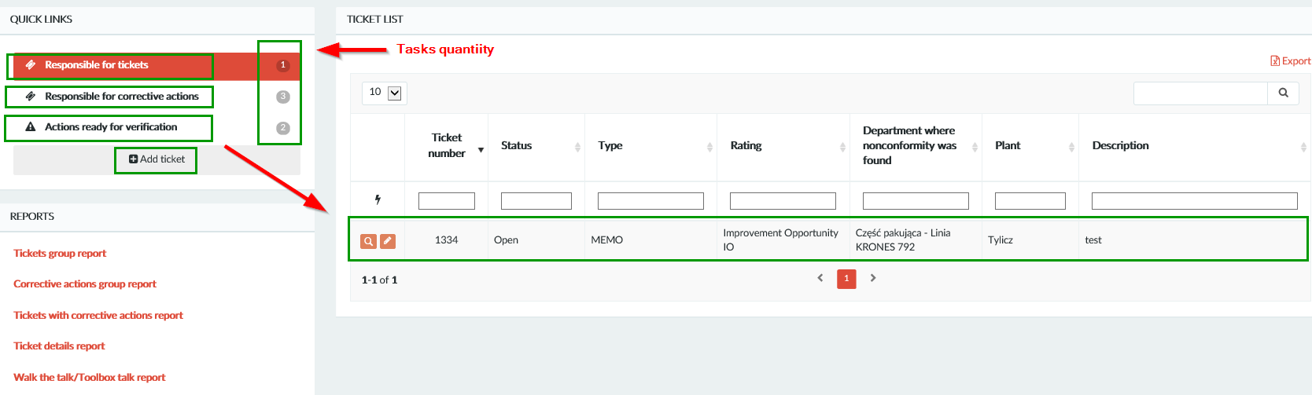

3.1.1. Responsible for tickets
In this section, we will find all tickets which we have been assigned as a person responsible for creating corrective actions. To check the list of tickets, click button "Responsible for tickets". A list of tickets will appear on the right.
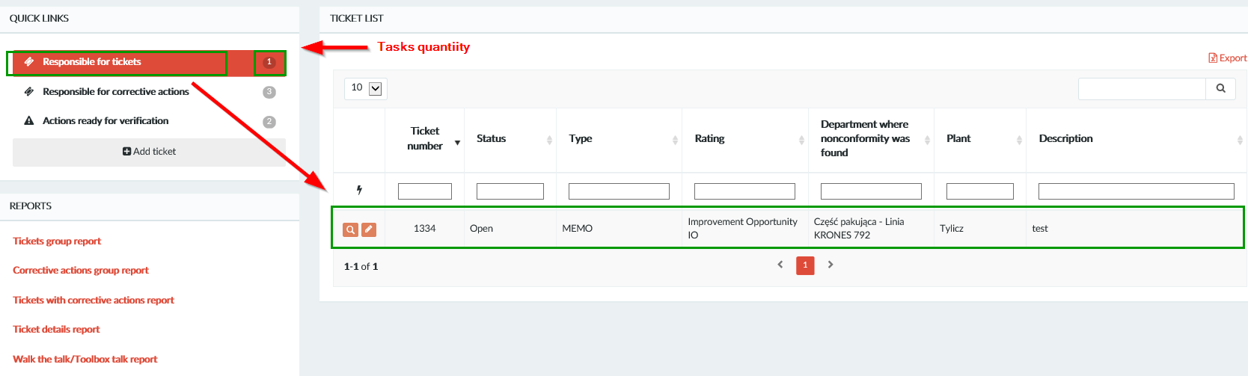

To create corrective action for selected ticket, click „Loupe” icon located on the left side on ticket list.

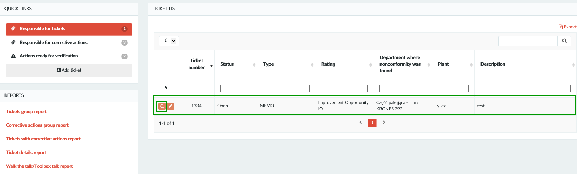

Click button „Create corrective action”.

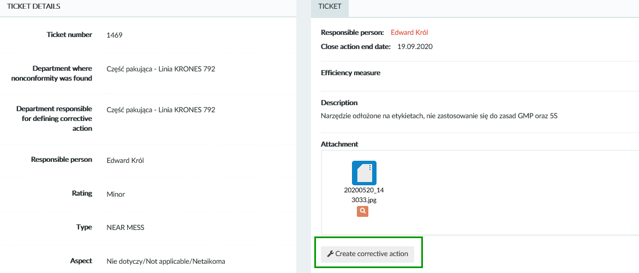

The next step is to complete the form for a new corrective action and confirm it with the "Save" button:
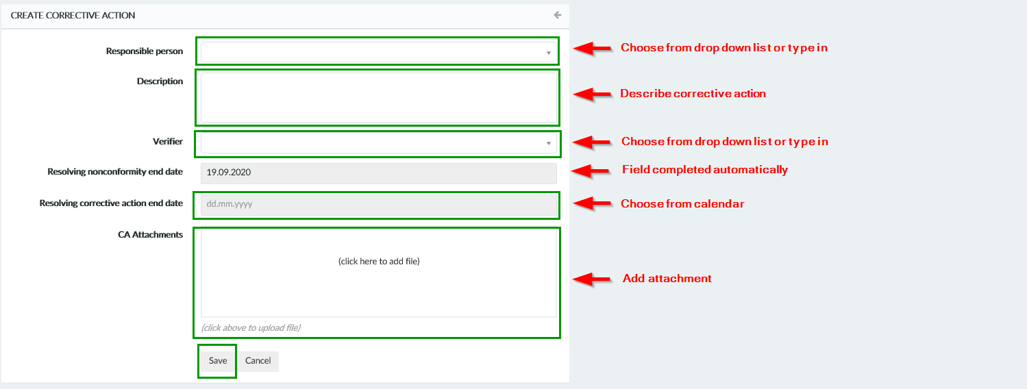

After saving the corrective action, we will be taken to the corrective action details window that we just created. To create another corrective action, click "Check Ticket" and follow the previous instructions. Click “Homepage” button to go to the next pending tasks.
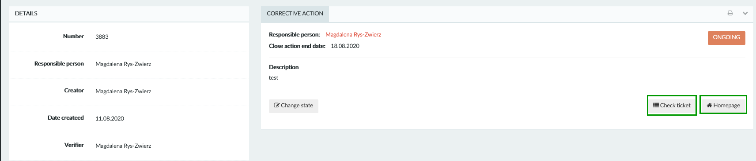

3.1.2. Responsible for corrective actions

This section contains all the corrective actions that should be done by us. To check the list of activities, click "Responsible for corrective actions". A list of activities will appear on the right.
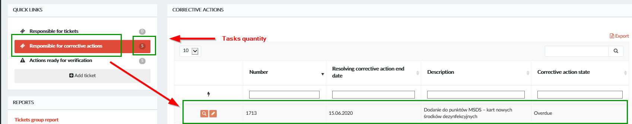

To display corrective action details and change state, click „Loupe” icon located on the left side on corrective action.
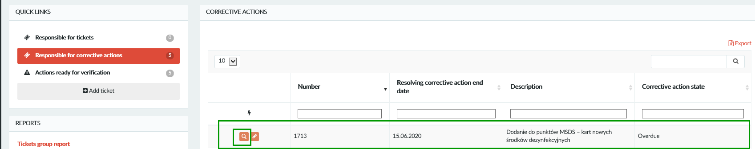
Click „Change state”.

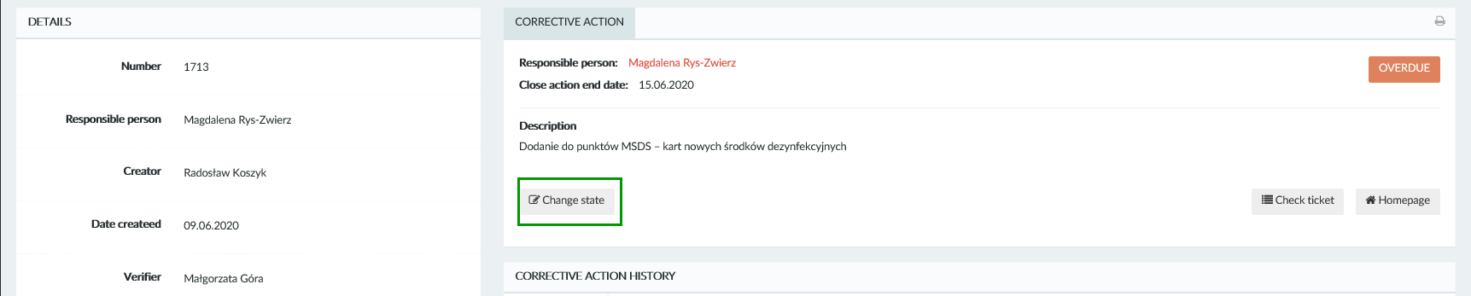

Choose right state from drop-down list:
- OnGoing
- Done
- Canceled

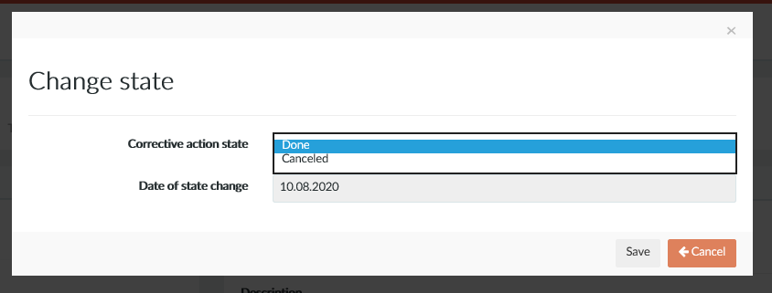

If you choose „Done” state you have to pick from the calendar end date of the corective action.

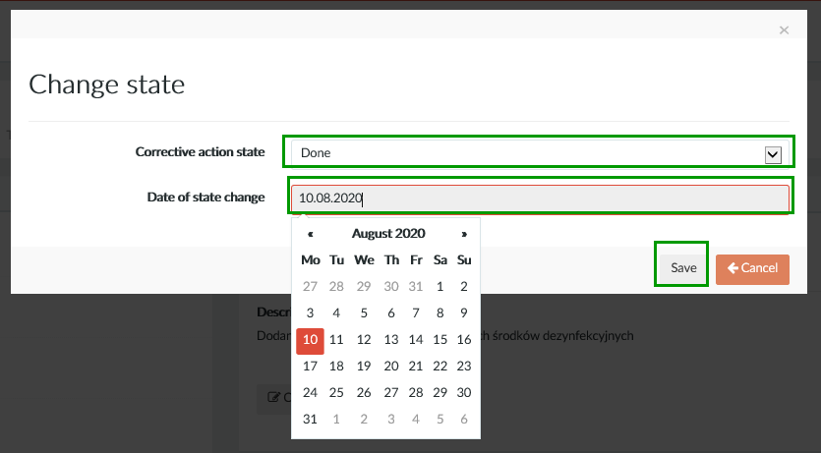

If you cancelled corrective action is necessary to provide comment with cancellation reason.

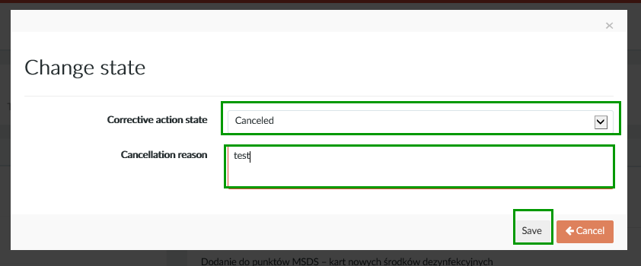

After saving the corrective action, we will be taken to the corrective action details window. To display ticket details, click "Check Ticket". Click “Homepage” button to go to the next pending tasks.

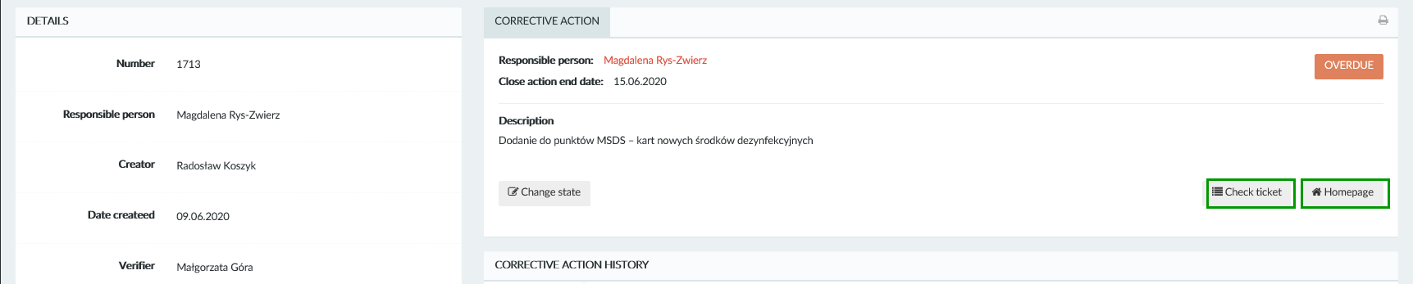

3.1.3. Action ready for verification
In this section we will find all activities where we have been assigned as a verifier. To check the list of them, click button "Action ready for verification". A list of actions will appear on the right.
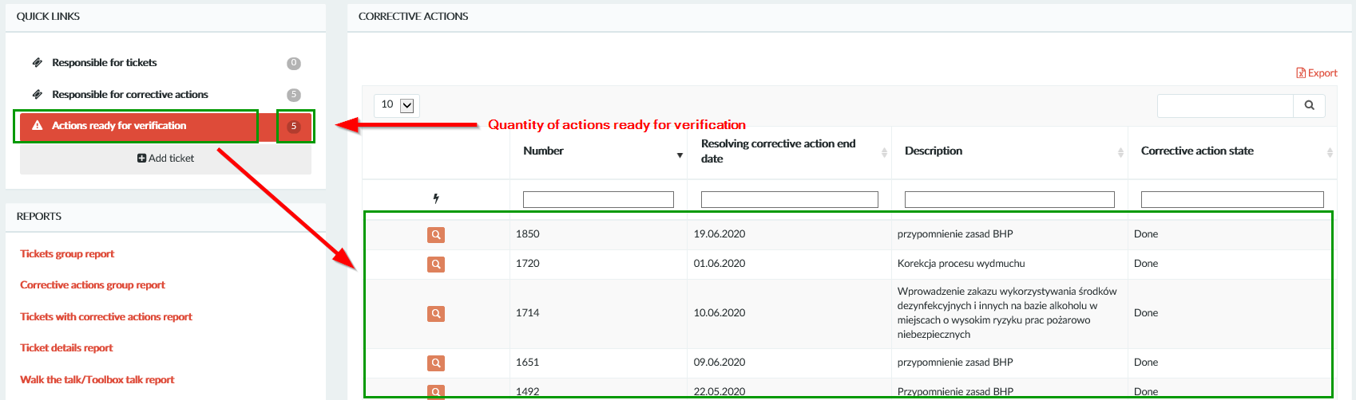

To change state of corrective action click „Loupe” icon located on left side of corrective action.

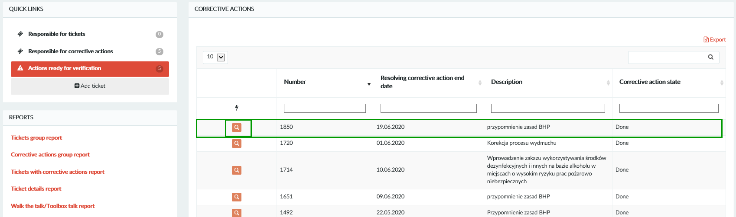

Click „Change state”.

Choose “Verified” state and complete verification description.

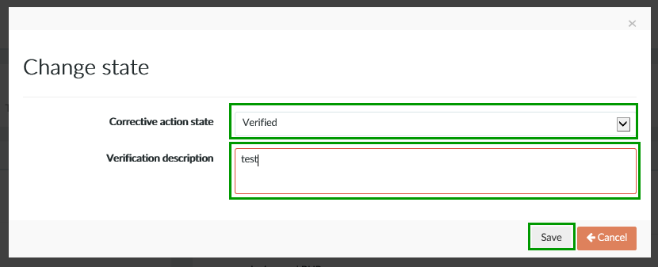

After saving the corrective action, we will be taken to the corrective action details window where you can add attachments. To display ticket details, click "Check Ticket". Click “Homepage” button to go to the next pending tasks.

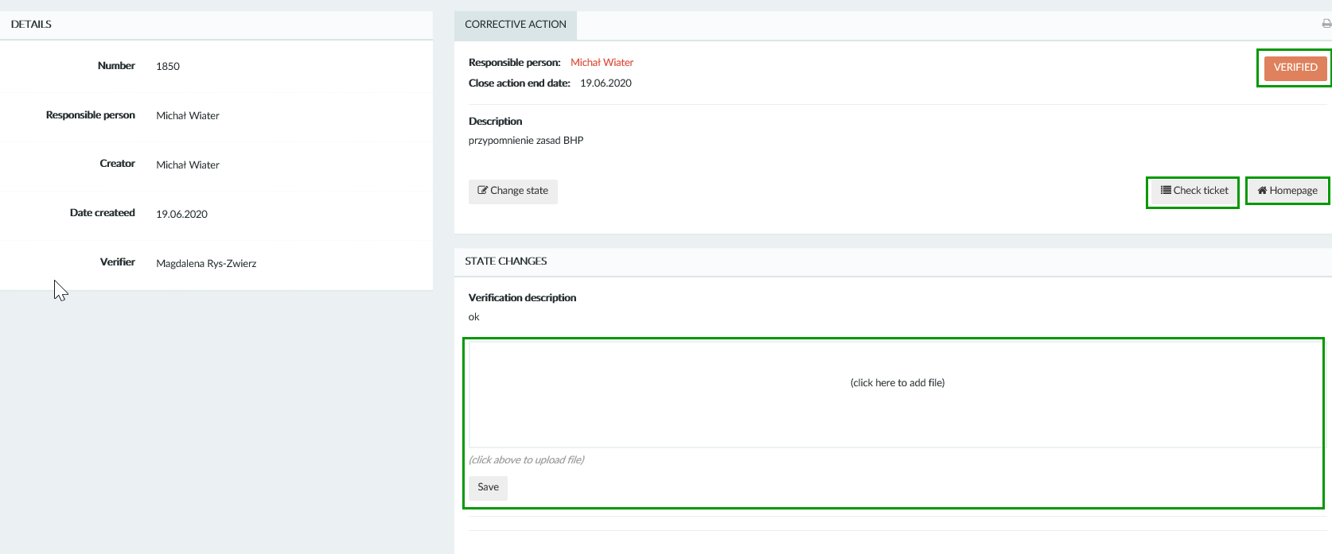

4. Tickets
Choose right commend (“Ticket list” or “Create new ticket”) from “Tickets” drop-down list.

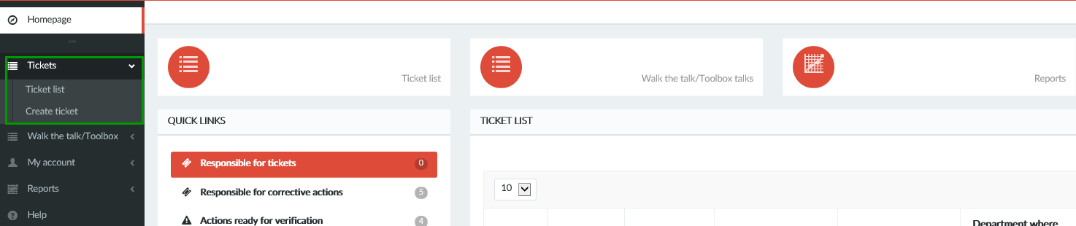

4.1. Ticket list

If you click “Ticket list” (in main menu or in middle panel) the tickets list will be displayed. This list will contain all created tickets.

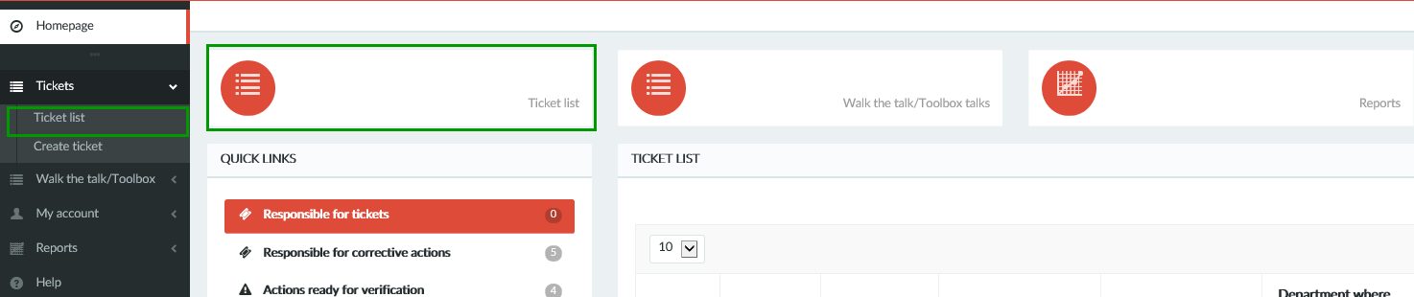

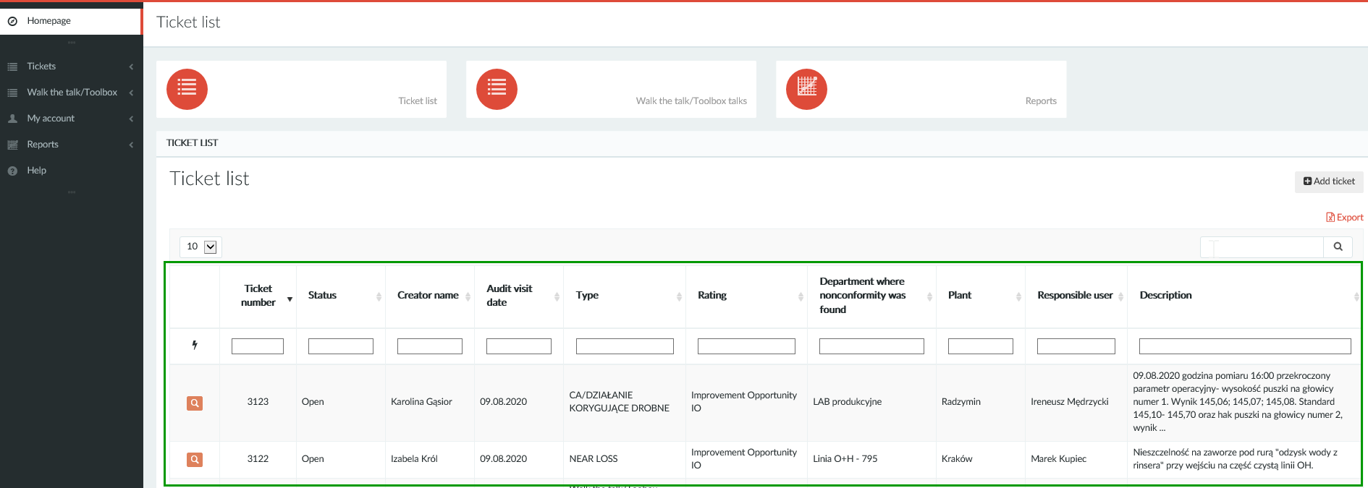

To every tickets are assigned icons:
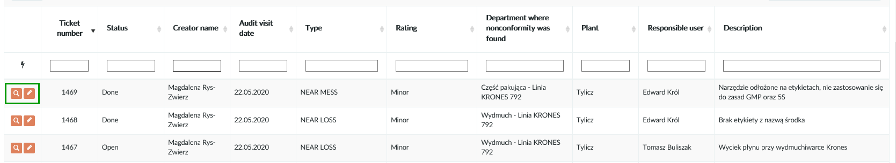

- „Loupe” – allows go to the details of the ticket
- „Pencil” – allows edit a tickets (this icon is visible only if you are responsible for this ticket, you are ticket creator or you have Admin roles)

You can use a fields under the list to quick search (one or several fields e.g. type and rating)
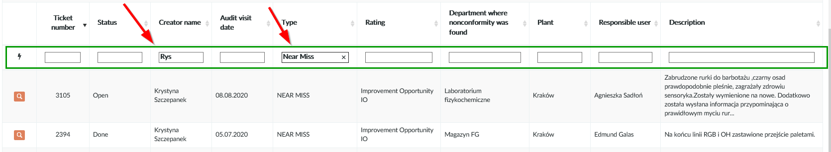

4.2. Create ticket
To create new ticket from the menu on the left select „Tickets” and then „Create ticket” or use button “Add ticket” on ticket list. This button is also available on user profile on main page.

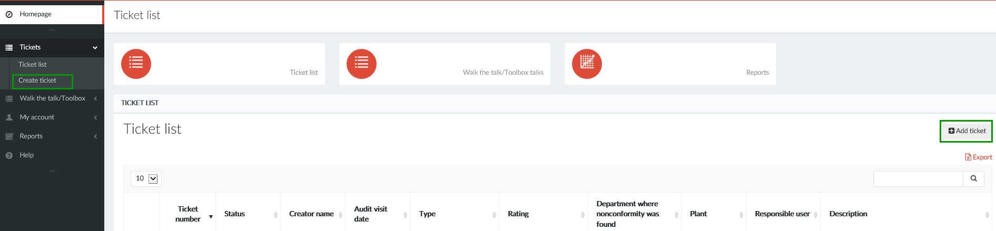
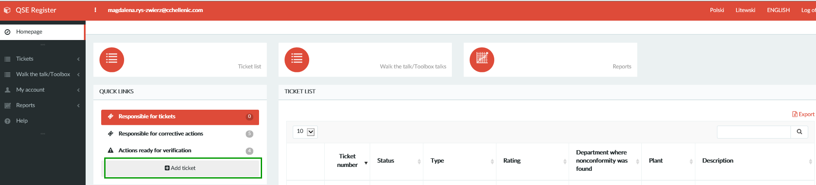

Fil up all fields in the form and click “Save ticket”. In case you miss some data, empty fields will be light.
Ticket form contains:
- Type of ticket (drop-down list )
- Creator name (filed completed automatically – you can change it)
- Plant (filed completed automatically – you can change it)
- Department where nonconformity was found (drop-down list or type in)
- Department responsible for defining corrective action (drop-down list or type in)
- Responsible person for defining corrective action (filed completed automatically – you can change it)
- Audit visit date (selected from calendar)

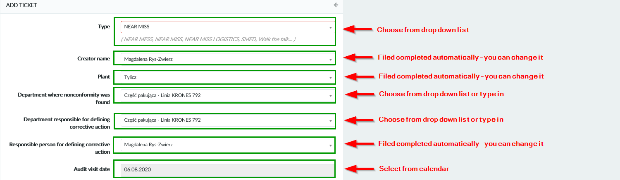

- Rating (drop-down list: Repetitive Major, Major, Critical, Repetitive IO, Minor, Improvement Opportunity IO, Repetitive Minor)
- Aspect (drop-down list or type in) if ticket is not Near Miss or Near Loss please use “Not applicable” from the list
- Nonconformity was found as results (drop-down list or type in):
- Audit/Inspection (internal or external)
- Microbiological out of standard
- Physicochemical out of standard
- Sensory (in the case of results NOK)
- EPL/OPL (in the case of downtimes)
- Environmental incident
- Quality of raw materials/ packing (in case of out of specification)
- Complaints
- GMP/5S (in the case of GMP/5S control)
- Health and Safety incident
- Warehousing (in case of nonconformilty according to finished good storage)
- Other
- Conducted (drop-down list or type in) – select activities which you conducted for e.g. behavioral audit, GMP/5S control, Toolbox talks, other
- Description (describe problem)
- Attachment
- If the nonconformity has already been removed, please mark checkbox " Ticket already Done" and then describe the actions performed in the field below

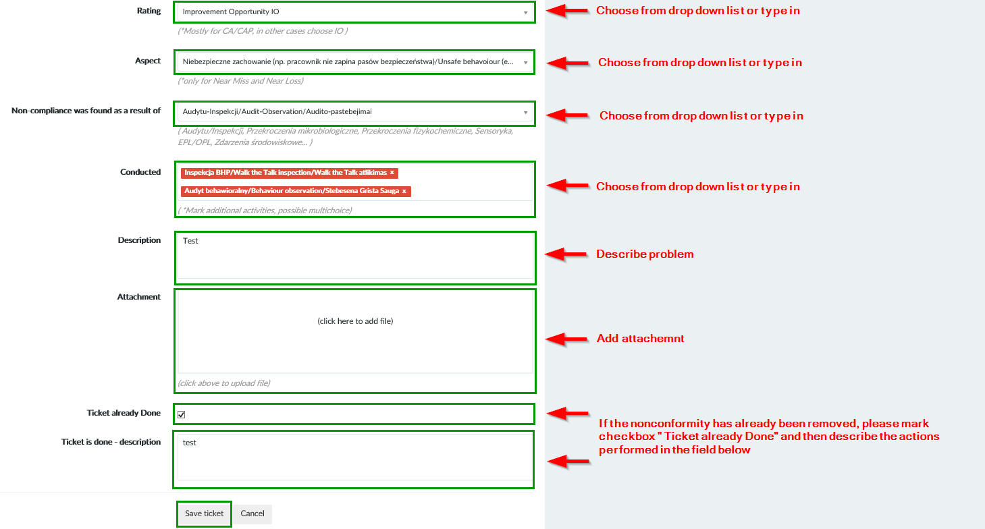

Depending of the chosen type of rating the system will generate automatically deadline for defining corective actions and ticket end date. After you create the ticket, the system will send notification by e-mail to person responsible for defining corective actions. In the e-mail will be attached directly link to the ticket.
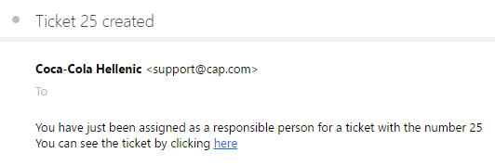

4.3. Ticket details
You can display details of the ticket by using „Loupe” icon located on the left side on the ticket.
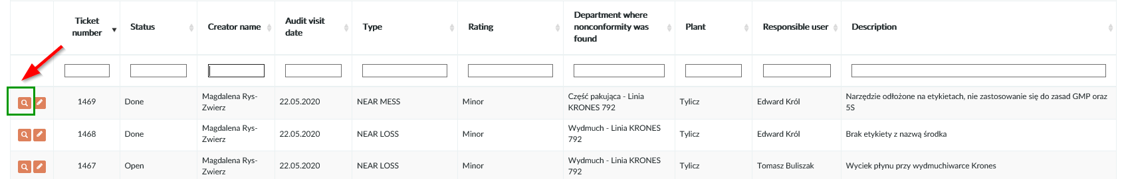

In ticket details you can find more information about (Fig.1), and list of corrective actions to this ticket (Fig. 2).

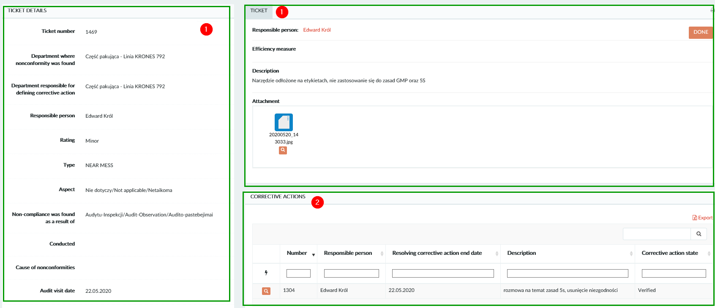

4.4. Ticket modification
To modify a ticket click “Pencil” button on the ticket list. Changes in ticket can be done by ticket creator and person responsible to ticket.
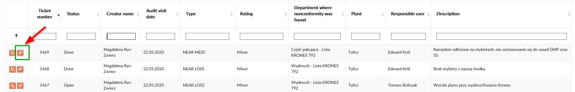

To apply changes click “Save ticket”.

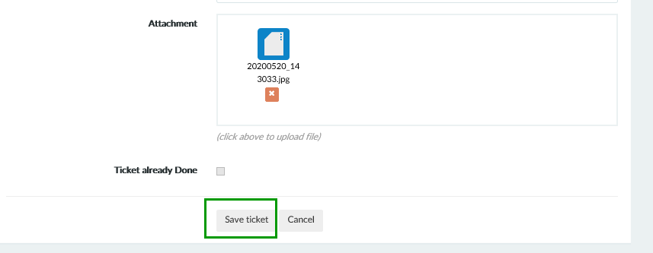

User with Admin roles can change all fields in the form also data set by system.

5. Corrective actions

5.1. Corrective action list
To display corrective action to selected ticket click „Loupe” icon located on the left side on ticket on the ticket list.

You can see ticket details view with list of corrective actions assigned to this ticket.
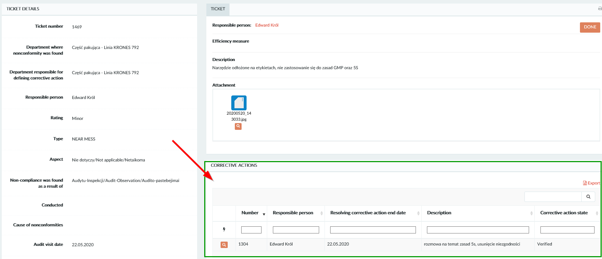

5.2. Corrective action details

To review corrective action details for selected action click „Loupe” icon located on the right side on the corrective action list. The „Pencil” icon for editing corective action will be visible only for responsible person for this corrective action.

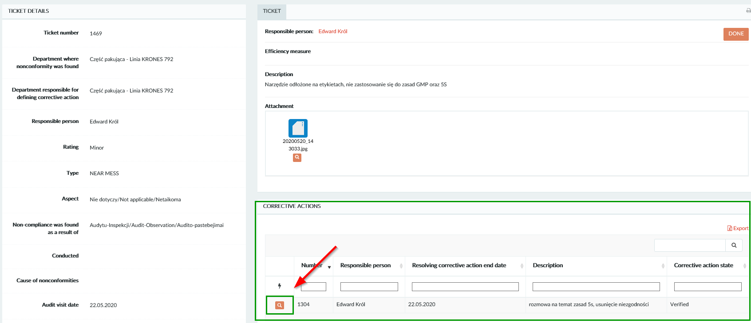

In corective action details window you can check for e.g. who is the ticket creator, who is the verifier. You can also review corective action history. You can open ticket details by clicking „Check ticket” button. Click “Homepage” button to go to main page of database. If you are verifier or responsible person by this corrective action “Change state” button will be visible.

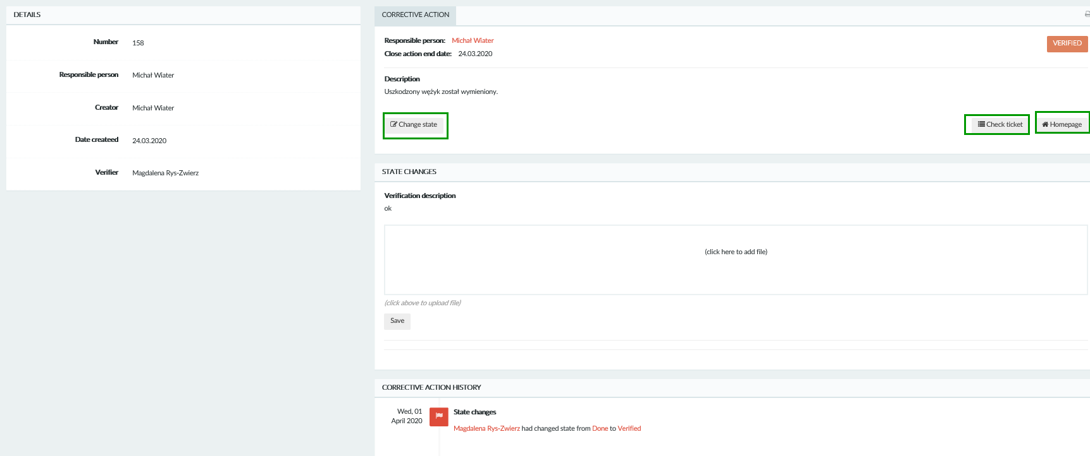

5.3. Changing of corrective action state

To change state of corrective action you need open selected corective action by „ Loupe” icon.
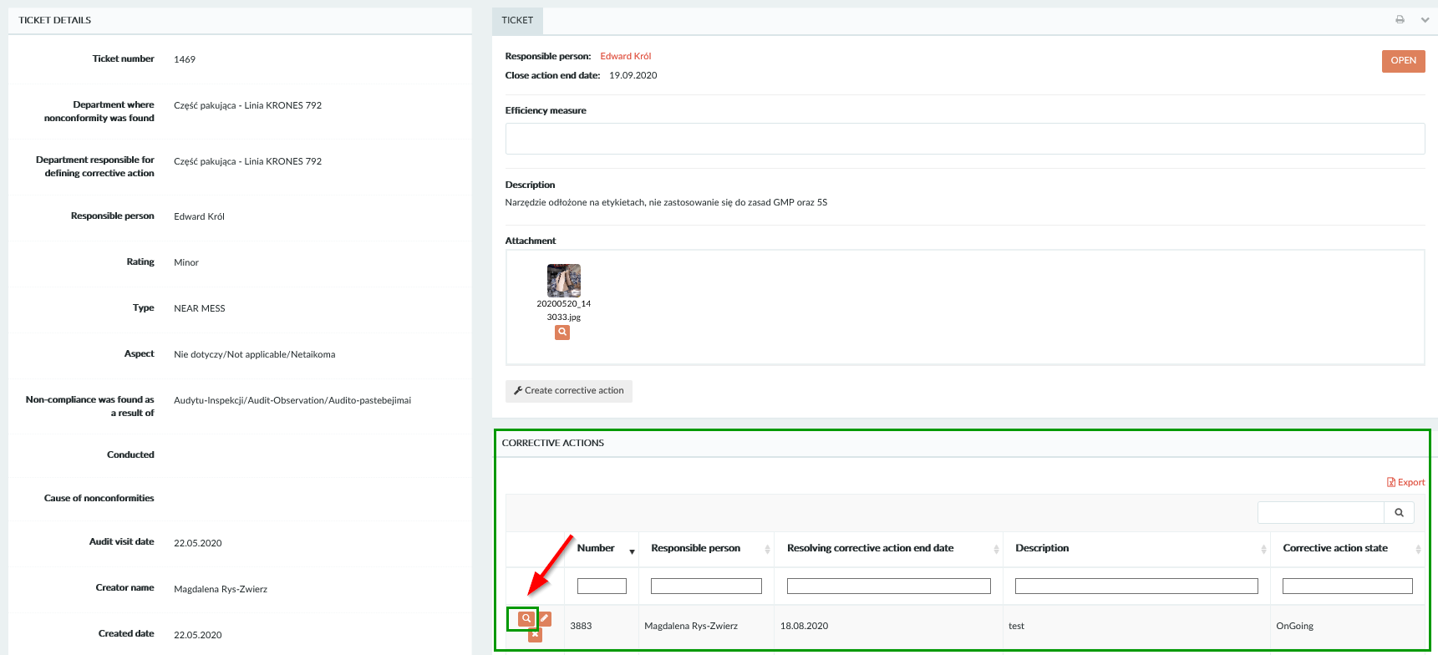

Click button “Change state”.
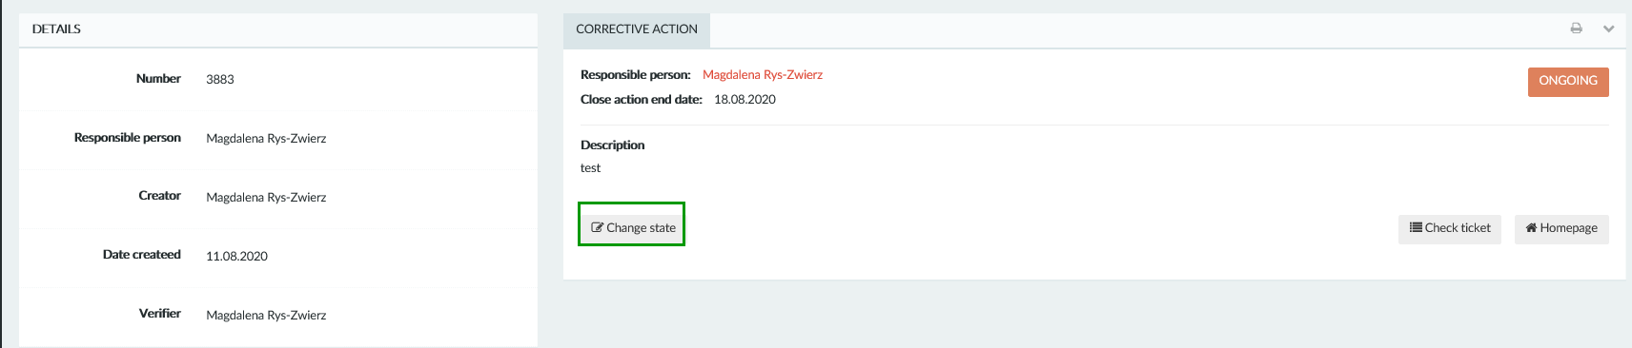

Choose right state from drop-down list:
- OnGoing
- Done
- Canceled

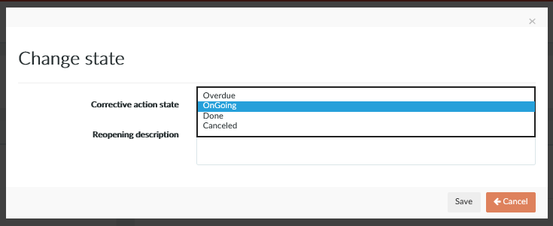

If you choose „Done” state you have to pick from the calendar end date of the corective action.

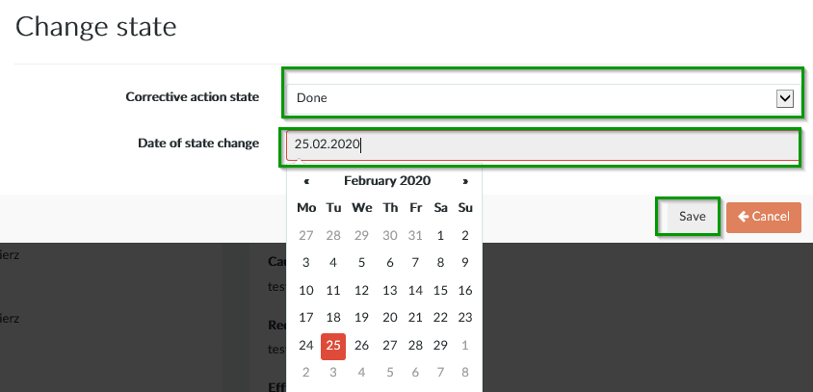

If you cancelled corrective action is necessary to provide comment with cancellation reason.

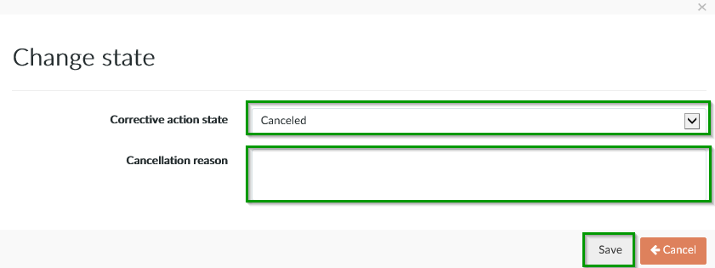

Option „Verified” is available only for person who verifies the corrective action.

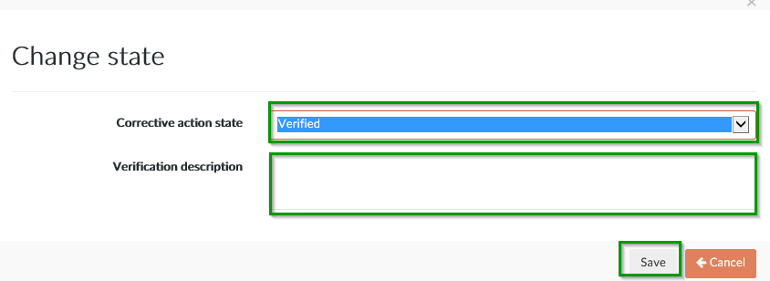

5.4. Corrective action creating
To create new corrective action click „Loupe” icon located on the left side on ticket list or follow instruction from 3.1.1. Responsible for tickets.

Click button ”Create corrective action”.

The next step is to complete the form for a new corrective action and confirm it with the "Save" button:

5.5. Modification of corrective action
To edit corrective action click „Loupe” icon located on the left on the list of corrective actions for the selected ticket.
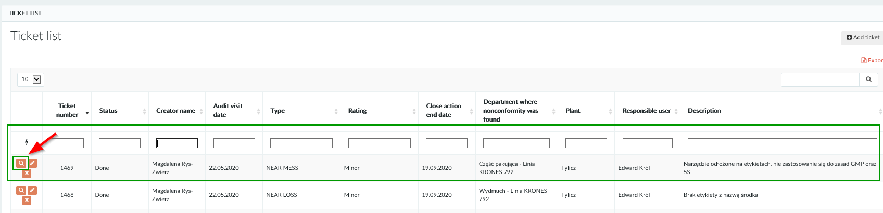

Next click „Pencil” icon for chosen corrective action.
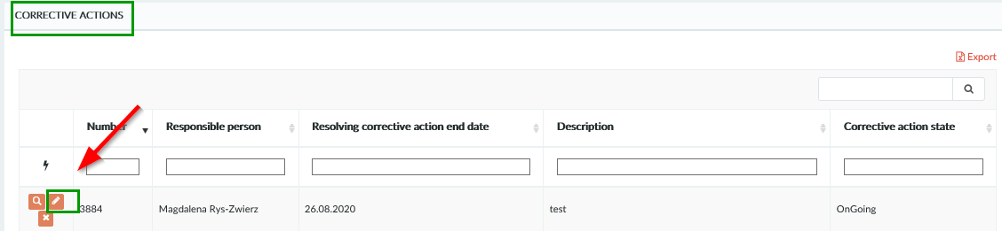

Make changes in to the form. If you change the "End date of corrective action" provide comment with the reason of delay. Confirm the changes with the "Save" button. Corrective actions can be removed only by the database administrator.

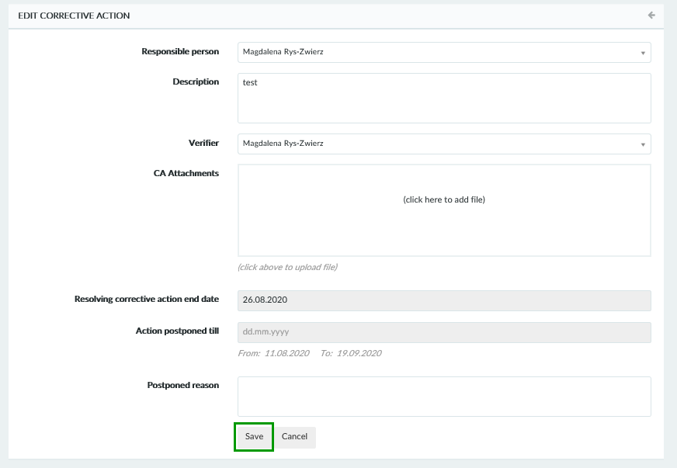

6. Walk the talk/Toolbox talks
By clicking „Walk the talk/Toolbox talks” from drop down menu, you can see list with available options: „List”, „Create new” and „Export report”.

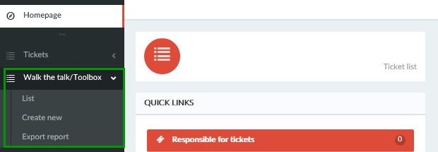

6.1. Walk the Talk/Toolbox Talks list
By clicking „List” from drop down menu or button on main page, window displays list with all Walk the talk/Toolbox talks inspections.

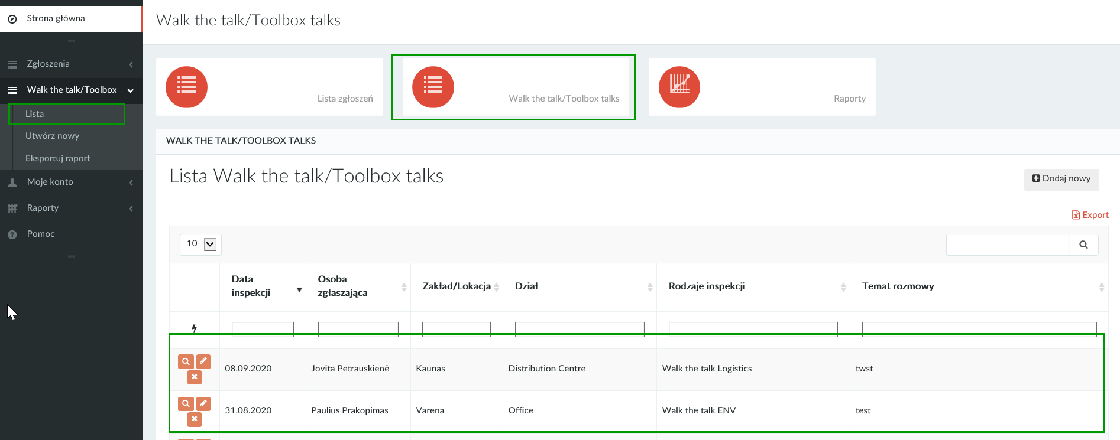

6.2. Create Walk the talk /Toolbox talks
To create a new Walk the talk / Toolbox talks, select "Create New" from the menu on the left and complete the form. Confirm it with the "Save" button.
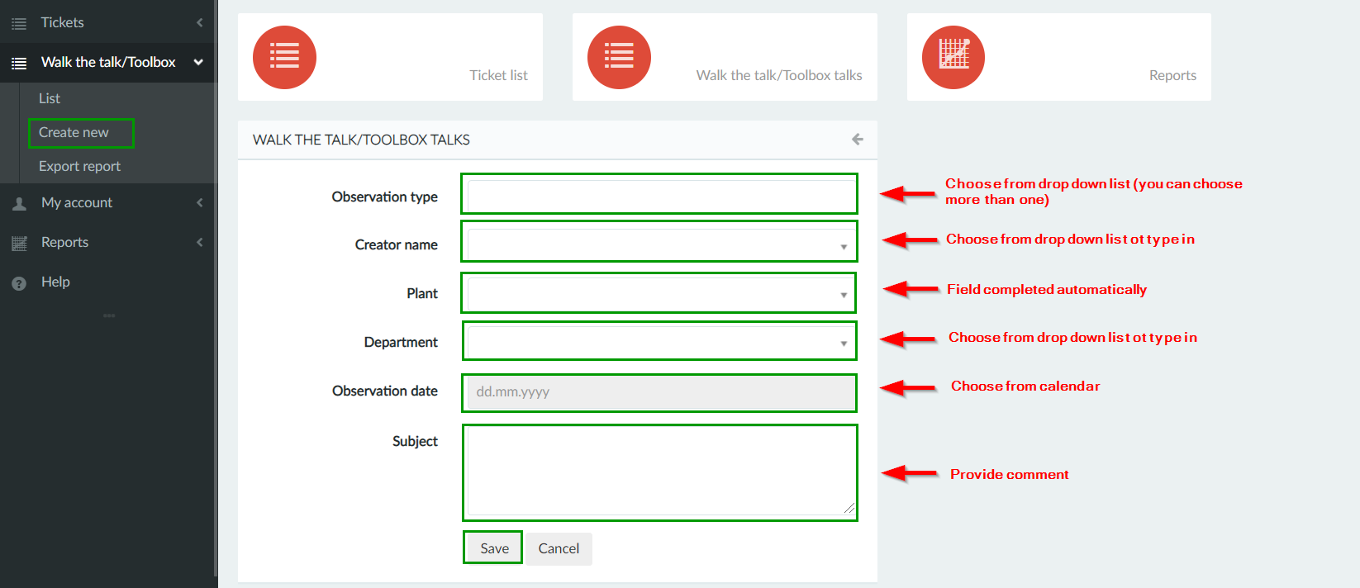

6.3. Creating Walk the talk/Toolbox talks report
By clicking "Export report" in the drop-down menu, will open report form. To check how create report please follow instruction from 8.4 Generating a Walk the talk / Toolbox talks report.
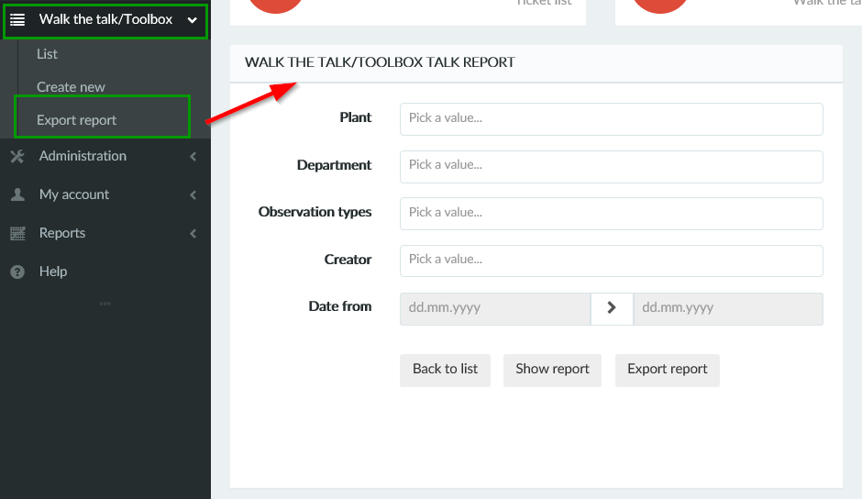

7. User account

7.1. My account
In “My account” menu you can find options: “My account” and Change password”.

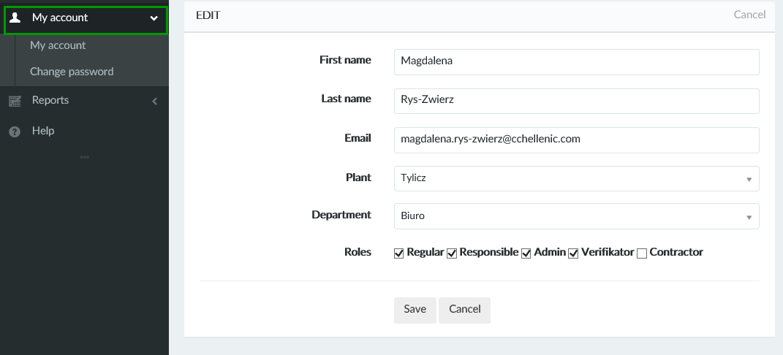

In tab “My account” you can edit personal data. Field department is read only. You can also see your roles in process. User roles can be changed only by Admin.

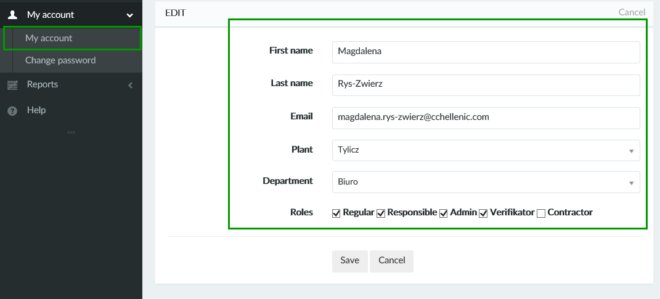

7.2. Change password
In tab “Change password” you can edit your current password.

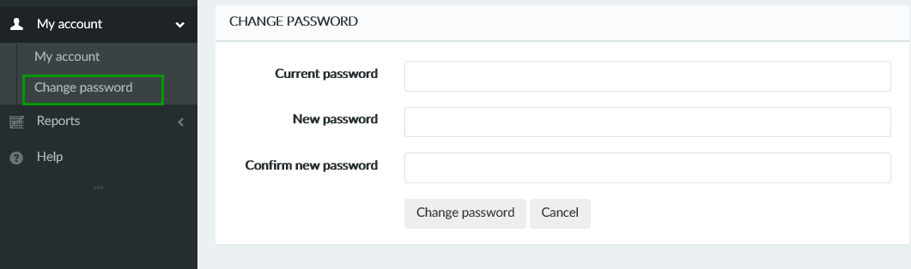

8. Reports

You can see available reports by clicking „Reports” from the menu or by using „Report” button located in the middle part of user page. You can also go to the report window using quick links on the main page.

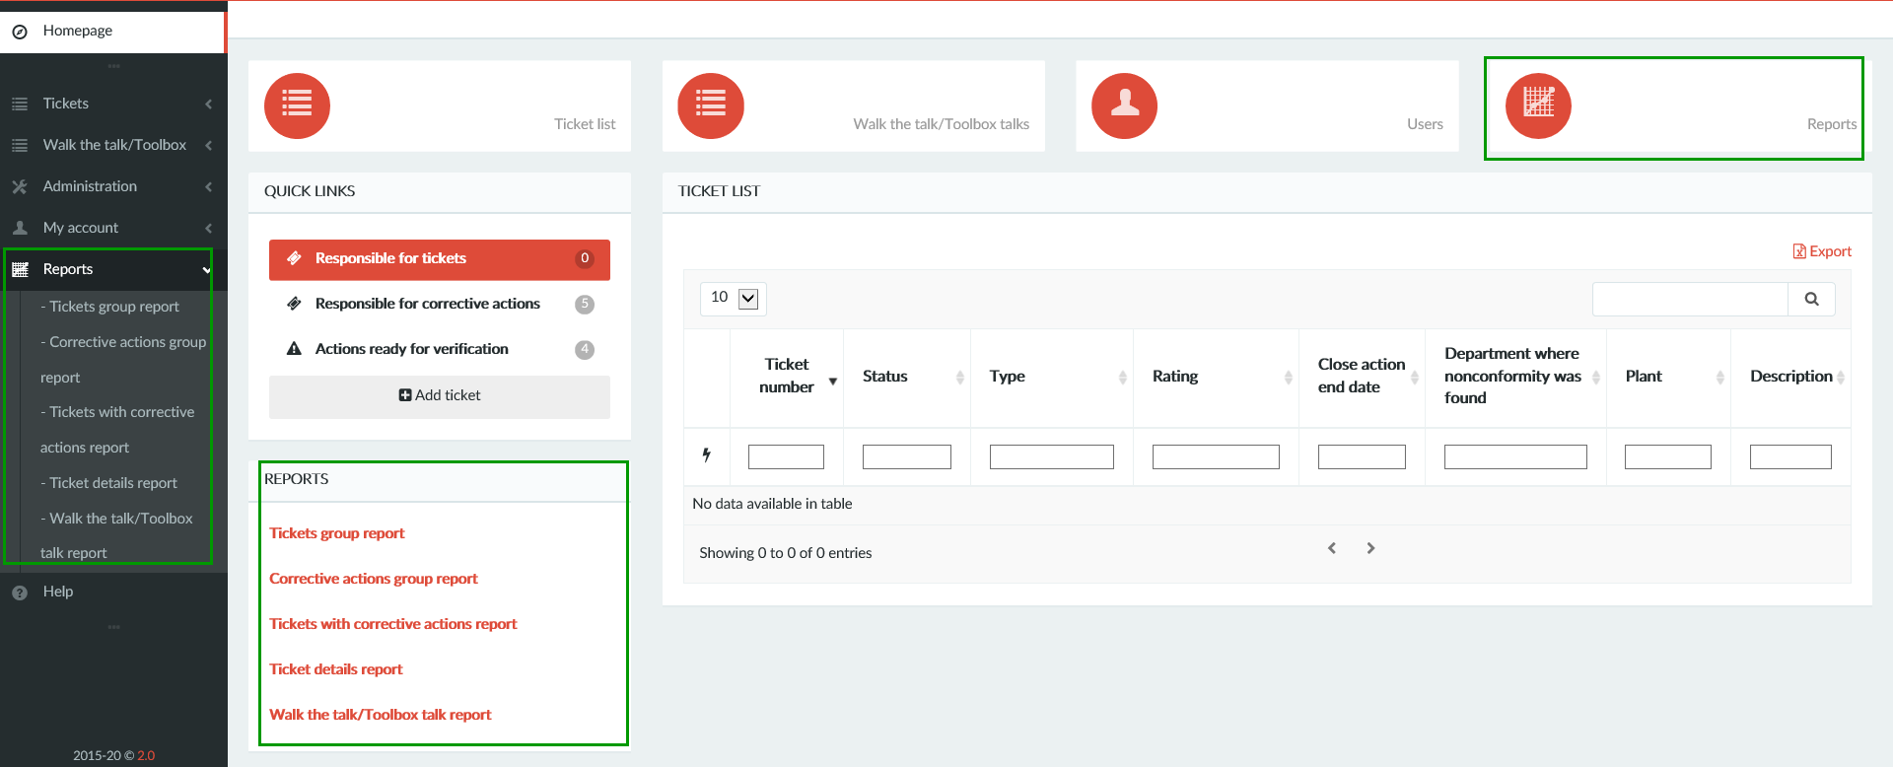

In database you can create 5 types of reports:

- Tickets group report –statistical data
- Corrective actions group report – statistical data
- Tickets with corrective actions report – details data
- Tickets details report - details data
- Walk the talk/Toolbox talks report – for inspection Walk the talk/Toolbox talks

8.1. Creating “Tickets group report” and “Corrective actions group report”

For “Tickets group report” and “Corrective actions group report” the way of creating reports are the same. To create report (“Tickets group report” or “Corrective actions group report”) choose right type report from the list or from the middle part of user panel or by using quick links on main page.
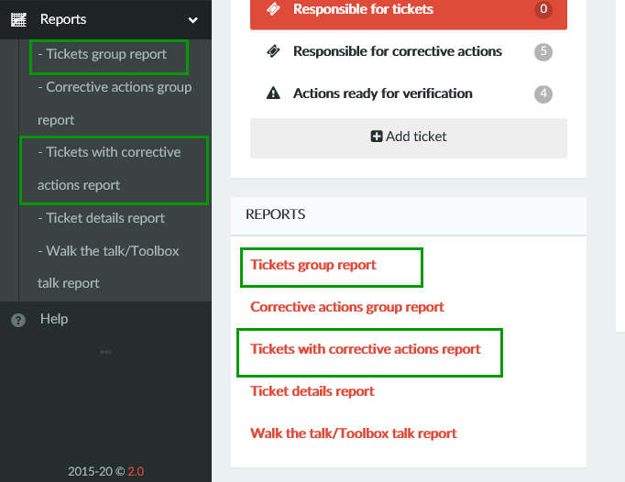
Please provide data for which you want create a report:
- Plant/Location (you can choose more than one) – if you do not fill this field, the report will contain tickets from all plants/locations
- Department (you can choose more than one) – if you do not fill this field, the report will contain tickets from all plants/locations
- Tickets type (you can choose more than one) – if you do not fill this field, the report will contain all types tickets for selected plants/locations
- Date range (only mandatory field – if you do not fill this field the report will be not created)
- If you want create report with only open tickets please mark the box „Show only open”
- If you want create report for Contractors please mark the box “Contractor”

Then press button „Show report”.

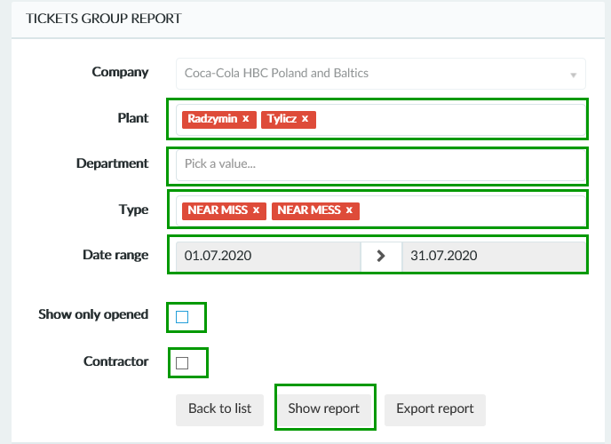

The report and chart will be generated. If You want generate report to Excel file please use button „Export report” and save the file on your computer. If you would like add or remove any data like departments or location, just edit the form and press button „Show report” again.

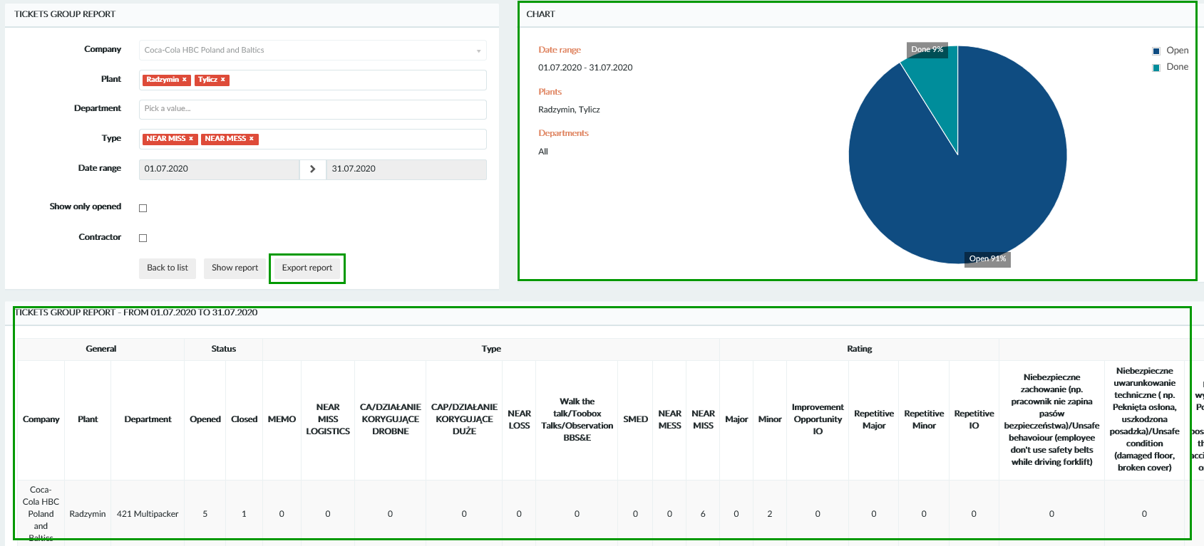

8.2. Creating „Corrective actions group report”
To create “Corrective actions group report” choose right type report from the list or by using quick links in the middle part of user panel.

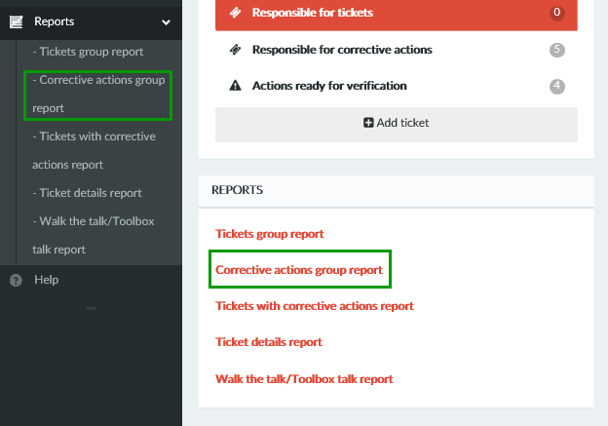

Please provide data for which you want create a report:
- Plant/Location (you can choose more than one) – if you do not fill this field, the report will contain corrective actions from all plants/locations
- Department (you can choose more than one) – if you do not fill this field, the report will contain corrective actions from all plants/locations
- Date range (only mandatory field – if you do not fill this field the report will be not created)
- If you want create report with only open corrective actions please mark the box „Show only open”
- If you want create report for Contractors please mark the box “Contractor”

In the report of corrective actions choosing the type of notification is not possible.

Then press button „Show report”.

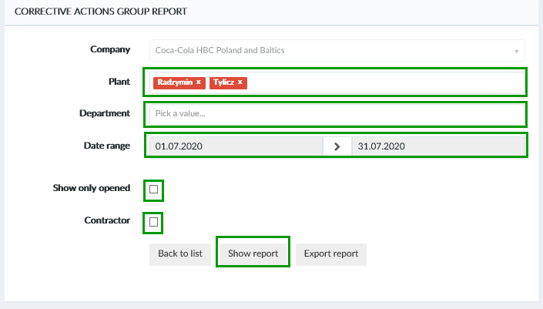
The report and chart will be generated. If You want generate report to Excel file please use button „Export report” and save the file on your computer. If you would like add or remove any data like departments or location , just edit the form and press button „Show report” again.

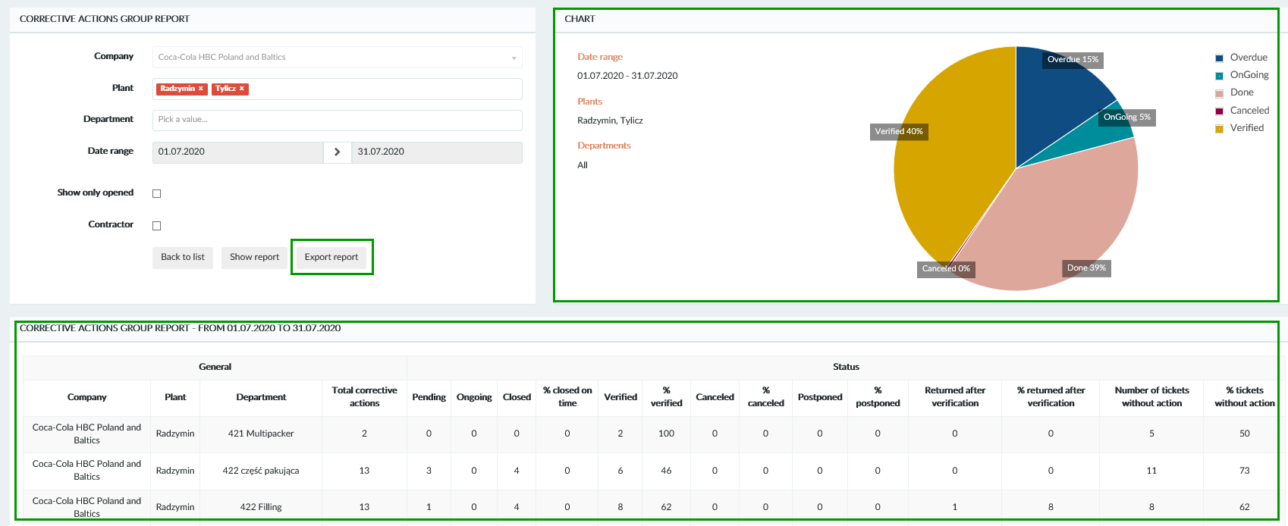

8.3. Creating „Ticket details report”
To create “Ticket details report” choose right type report from the list or by using quick links in the middle part of user panel.

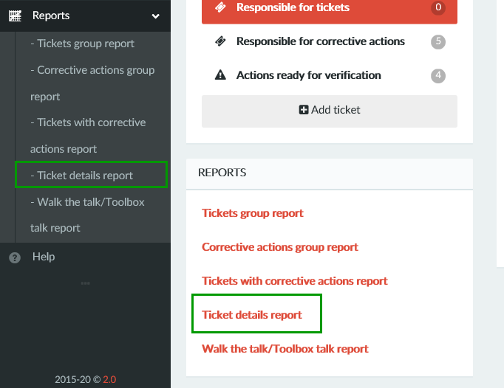

Please provide data for which you want create a report:
- Plant/Location (you can choose more than one) – if you do not fill this field, the report will contain tickets from all plants/locations
- Department (you can choose more than one) – if you do not fill this field, the report will contain tickets from all plants/locations
- Tickets type (you can choose more than one) – if you do not fill this field, the report will contain all types tickets for selected plants/locations
- Date range (only mandatory field – if you do not fill this field the report will be not created)
- Ticket creator (you can choose more than one) – if you do not fill this field, the report will be created for all creators
- Responsible person (you can choose more than one) – if you do not fill this field, the report will be created for all
- If you want create report with only open tickets please mark the box „Show only open”
- If you want create report for Contractors please mark the box “Contractor”

Then press button „Show report”.
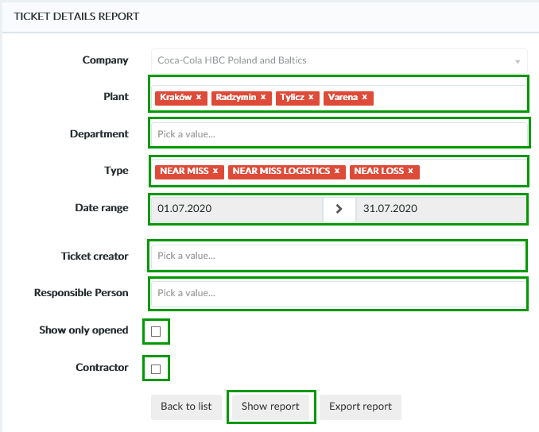

The report and chart will be generated. If You want generate report to Excel file please use button „Export report” and save the file on your computer. If you would like add or remove any data like departments or location , just edit the form and press button „Show report” again.

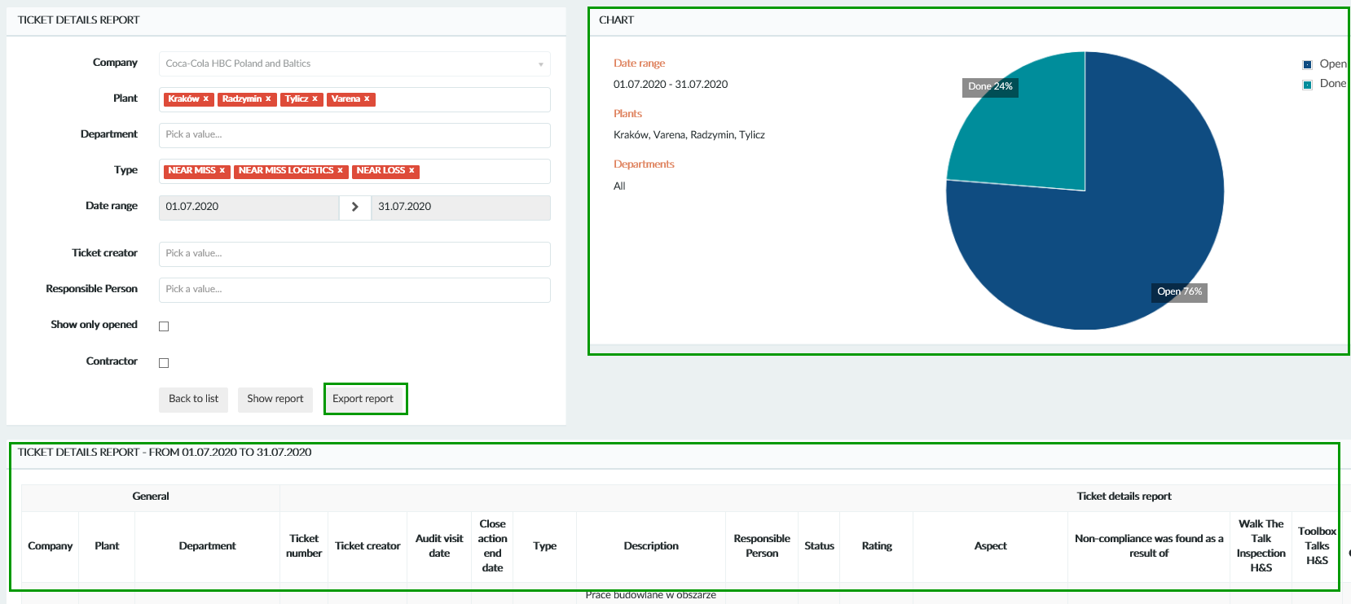

8.4. Creating „Walk the talk/Toolbox talks report”
You can create ”Walk the talk/Toolbox talks report” in several ways:
- by clicking “Reports” from the drop down menu and then „Walk the talk/Toolbox talks report”
- by quick links in the middle part of user panel
- by clicking „Walk the talk/Toolbox talks” from the drop down menu and then „Export report”

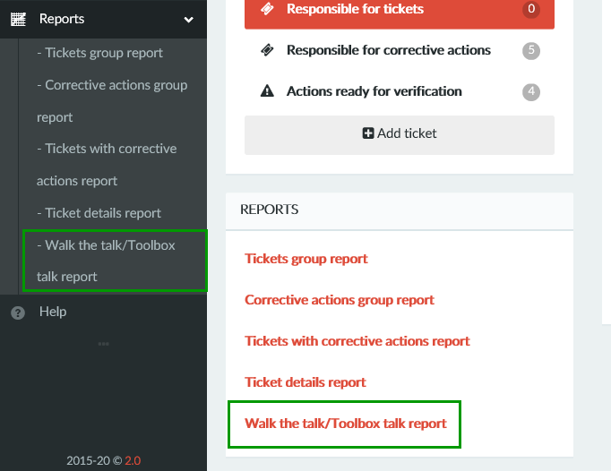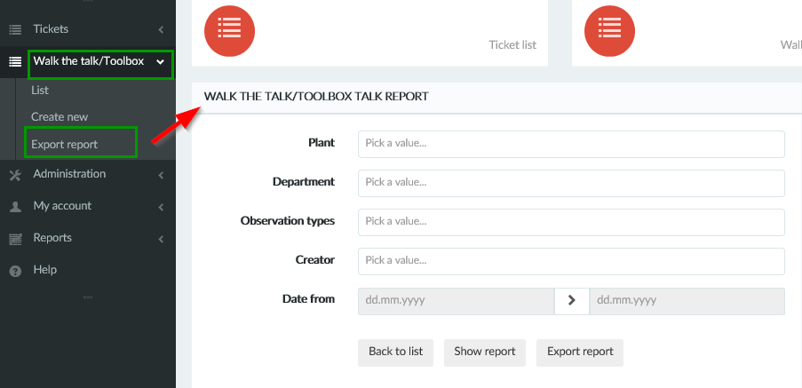

Please provide data for which you want create a report:
- Plant/Location (you can choose more than one) – if you do not fill this field, the report will contain inspections from all plants/locations
- Department (you can choose more than one) – if you do not fill this field, the report will contain inspections from all plants/locations
- Inspections type (you can choose more than one) – if you do not fill this field, the report will contain all types inspections for selected plants/locations
- Creator (you can choose more than one) – if you do not fill this field, the report will be created for all creators
- Date range (only mandatory field – if you do not fill this field the report will be not created)

Then press button „Show report”.

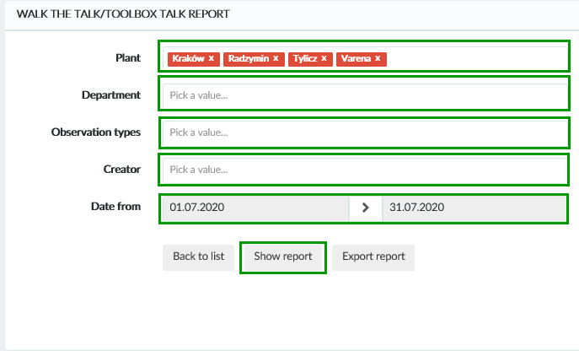
The report and chart will be generated. If You want generate report to Excel file please use button „Export report” and save the file on your computer. If you would like add or remove any data like departments or location , just edit the form and press button „Show report” again.

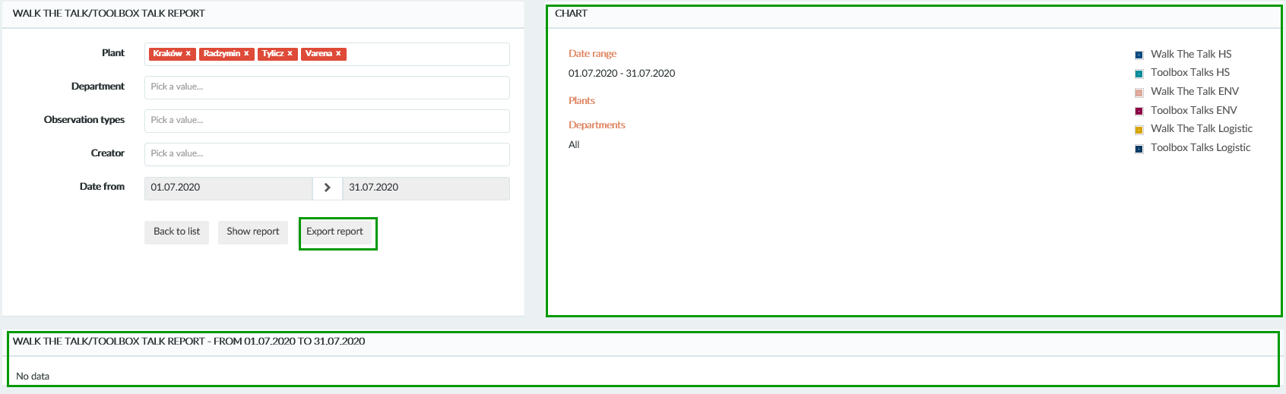

9. Pomoc
By clicking "Help" button in the menu on the left, a page with the attached user manual of the database will open.

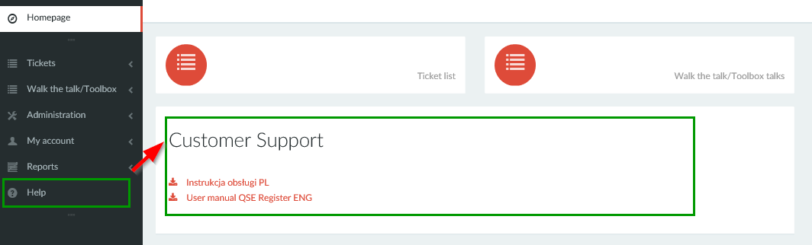

10. Automatic notifications

The application has the functionality that periodically sends an automatic notification. There are 6 types of automatic notification.

- When the deadline for closing the ticket or for the closure of all corrective actions related to the ticket expires. The responsible person receives notification.

- When the deadline for the closure of corrective actions expires. Notification is sent to the responsible person.

- When the deadline for defining a corrective action for the ticket is expired. Notification is sent to the responsible person.

- Every Monday notification is sent as a reminder about open corrective actions. Notification is sent to the responsible person.

- Every 28th of current month notification will be sent as a reminder about open corrective actions. Notification is sent to the responsible person.

- Every 28th of current month notification will be sent as a reminder about corrective actions ready for verification. Notification is sent to the verifier.

11. Technical support
If an error message appears while the database is running, press CTRL + "F5" or "FN" + F5. The browser will refresh the page and the error probably will be removed.

If difficulty during using database will still occur, please send email with description of error to: support@parallel-web.com

In the message please include information below:
- Description of the activity during the error occurred (creating notifications, changing the status of corrective action, you received a notification that should not reach you, etc.)
- The name of the page you are connecting to (it's best to copy the link from the browser)
- Browser name (Explorer, Chrome, Firefox)
- Operating system (Windows 7/8/10, Linux, Mac OS X or other)
- Every detail you think is important so that we can reproduce the error as close as possible

